**SOCIAL NETWORK ANALYSIS**

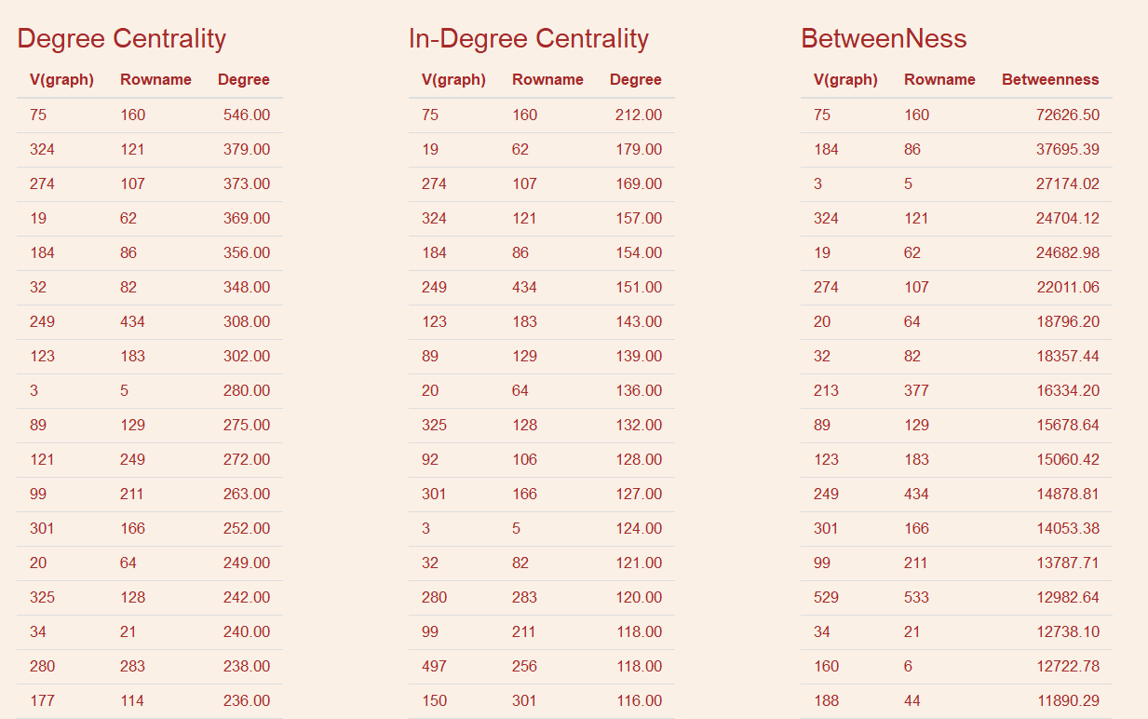

As per the visualizations, the Employee with code **160** has the maximum degree centrality , in degree centrality and betweenness.

This implies that the Employee 160, is the most important employee and receives the maximum number of emails. Also, the employee 160 is the most important for the connectivity.

The top 10 employees in all the above three categories have 8 employees in common. This implies that most important employees are the one who gets the maximum number of mails and they are most connected employee via mail. They are also the people who acts as a bridge between the departments.